# Matplotlib Pie Charts

## **Creating Pie Charts**

With Pyplot, you can use the pie() function to draw pie charts:

### **Example**

A simple pie chart:

import matplotlib.pyplot as plt  
import numpy as np  
  
y = np.array([35, 25, 25, 15])  
  
plt.pie(y)  
plt.show()

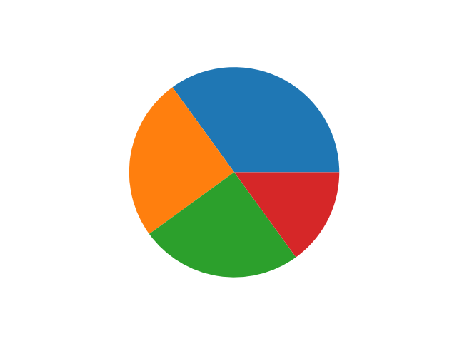

As you can see the pie chart draws one piece (called a wedge) for each value in the array (in this case [35, 25, 25, 15]).

By default the plotting of the first wedge starts from the x-axis and move counterclockwise:

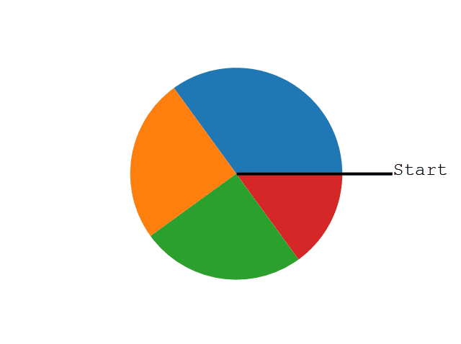

## **Labels**

Add labels to the pie chart with the label parameter.

The label parameter must be an array with one label for each wedge:

### **Example**

A simple pie chart:

import matplotlib.pyplot as plt  
import numpy as np  
  
y = np.array([35, 25, 25, 15])  
mylabels = ["Apples", "Bananas", "Cherries", "Dates"]  
  
plt.pie(y, labels = mylabels)  
plt.show()

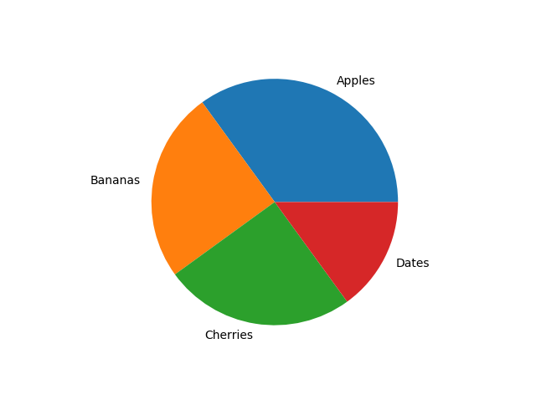

## **Start Angle**

As mentioned the default start angle is at the x-axis, but you can change the start angle by specifying a startangle parameter.

The startangle parameter is defined with an angle in degrees, default angle is 0:

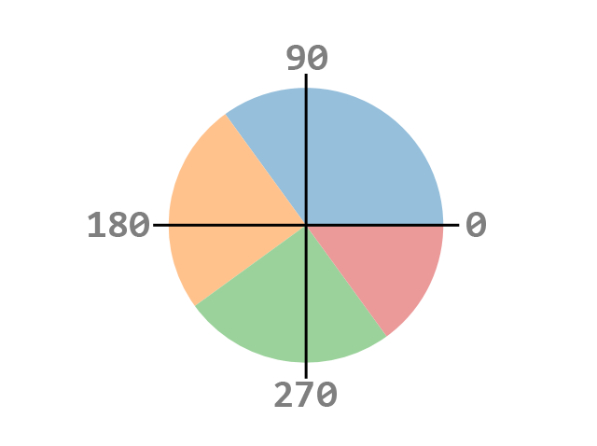

### **Example**

Start the first wedge at 90 degrees:

import matplotlib.pyplot as plt  
import numpy as np  
  
y = np.array([35, 25, 25, 15])  
mylabels = ["Apples", "Bananas", "Cherries", "Dates"]  
  
plt.pie(y, labels = mylabels, startangle = 90)  
plt.show()

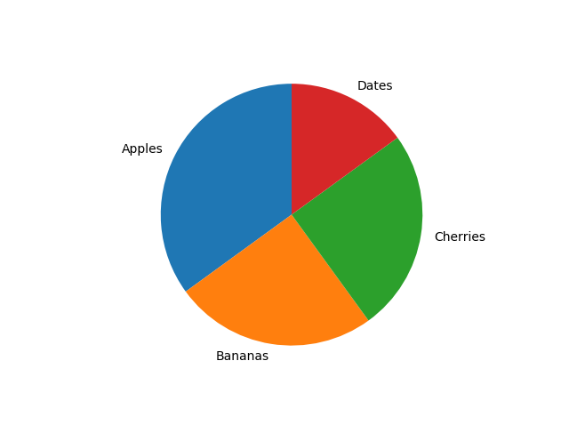

## **Explode**

Maybe you want one of the wedges to stand out? The explode parameter allows you to do that.

The explode parameter, if specified, and not None, must be an array with one value for each wedge.

Each value represents how far from the center each wedge is displayed:

### **Example**

Pull the "Apples" wedge 0.2 from the center of the pie:

import matplotlib.pyplot as plt  
import numpy as np  
  
y = np.array([35, 25, 25, 15])  
mylabels = ["Apples", "Bananas", "Cherries", "Dates"]  
myexplode = [0.2, 0, 0, 0]  
  
plt.pie(y, labels = mylabels, explode = myexplode)  
plt.show()

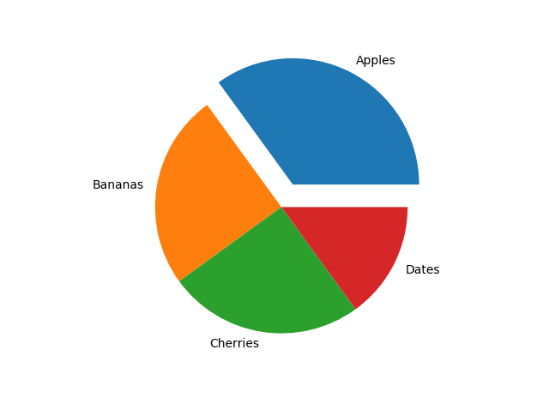

## **Shadow**

Add a shadow to the pie chart by setting the shadows parameter to True:

### **Example**

Add a shadow:

import matplotlib.pyplot as plt  
import numpy as np  
  
y = np.array([35, 25, 25, 15])  
mylabels = ["Apples", "Bananas", "Cherries", "Dates"]  
myexplode = [0.2, 0, 0, 0]  
  
plt.pie(y, labels = mylabels, explode = myexplode, shadow = True)

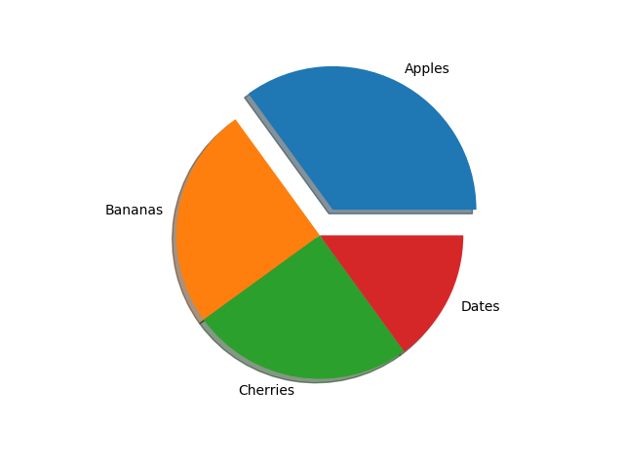

## **Colors**

You can set the color of each wedge with the colors parameter.

The colors parameter, if specified, must be an array with one value for each wedge:

### **Example**

Specify a new color for each wedge:

import matplotlib.pyplot as plt  
import numpy as np  
  
y = np.array([35, 25, 25, 15])  
mylabels = ["Apples", "Bananas", "Cherries", "Dates"]  
mycolors = ["black", "hotpink", "b", "#4CAF50"]  
  
plt.pie(y, labels = mylabels, colors = mycolors)  
plt.show()

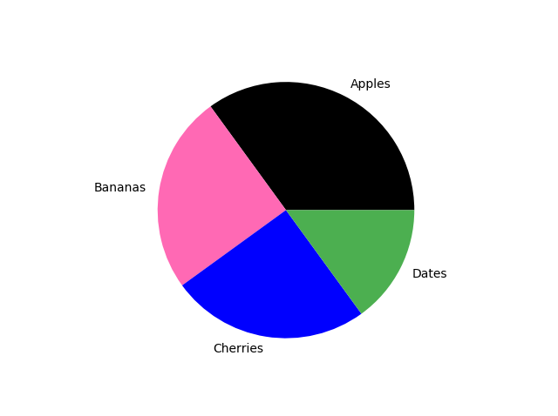

'r' - Red  
'g' - Green  
'b' - Blue  
'c' - Cyan  
'm' - Magenta  
'y' - Yellow  
'k' - Black  
'w' - White

## **Legend**

To add a list of explanation for each wedge, use the legend() function:

### **Example**

Add a legend:

import matplotlib.pyplot as plt  
import numpy as np  
  
y = np.array([35, 25, 25, 15])  
mylabels = ["Apples", "Bananas", "Cherries", "Dates"]  
  
plt.pie(y, labels = mylabels)  
plt.legend()  
plt.show()

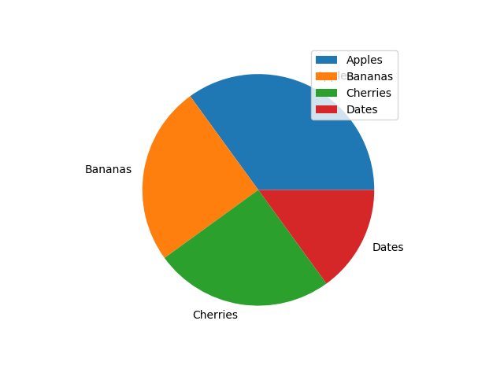

### **Legend With Header**

To add a header to the legend, add the title parameter to the legend function.

### **Example**

Add a legend with a header:

import matplotlib.pyplot as plt  
import numpy as np  
  
y = np.array([35, 25, 25, 15])  
mylabels = ["Apples", "Bananas", "Cherries", "Dates"]  
  
plt.pie(y, labels = mylabels)  
plt.legend(title = "Four Fruits:")  
plt.show()

